TEST RESULTS

After determining required component and designing schematic of the circuit, design is made on pertinax. Two pertinaxes are used for the isolating the primary and secondary sides. At the primary side, switch, input connections, controller, diode and one side of the transformer and buck regulator for feeding controller are placed. On the other hand, at secondary pertinax, feedback circuit, freewheeling diodes, inductor, capacitor and optocoupler and feedback circuits are placed. For cool down the MOSFET, fan is placed at the primary side.

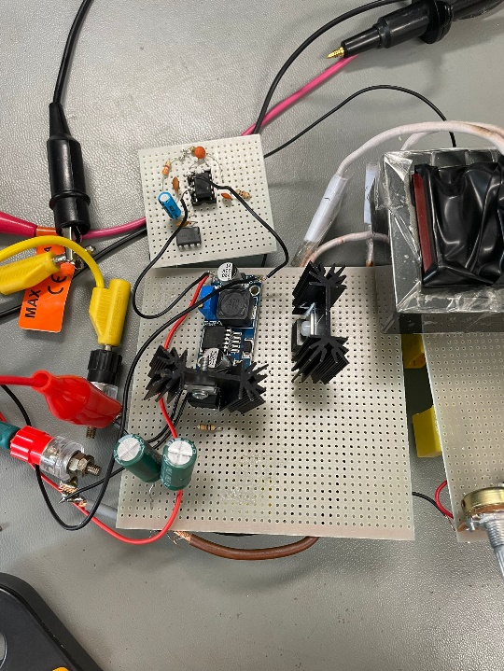

Figure X. Primary Side of the Converter

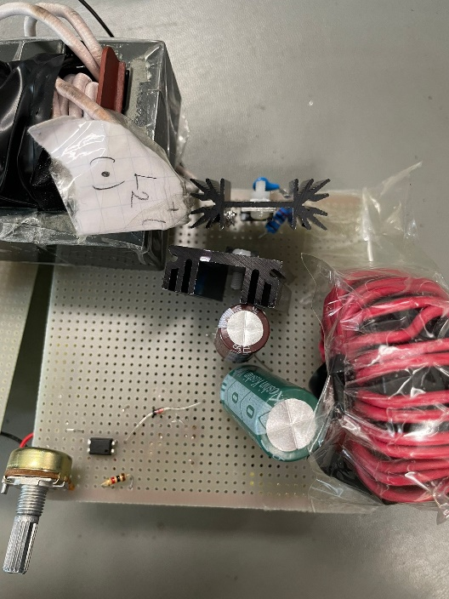

Figure X. Secondary Side of the Converter

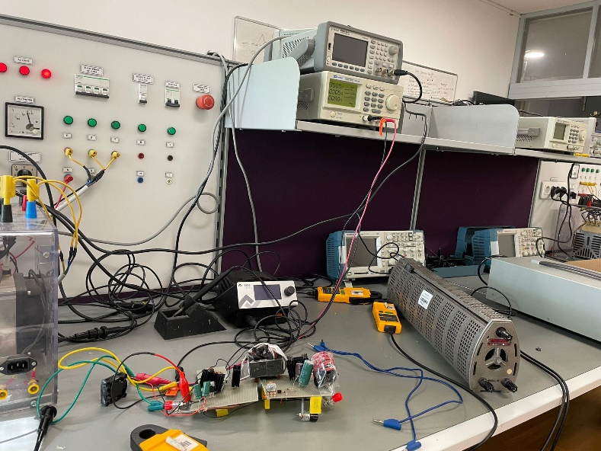

Figure X. Test Setup for the Converter

For testing the designed forward converter, dc power supply is used for input power. Used load is high power low resistance resistor. This resistor is varying between 0 ohm to 26 ohm. Testing procedure is started from 24 ohm which is 10% load. Then, load goes to full load case. At the testing period, our circuit is operating well at low loads. Changing load or input voltage, 12 V at the output side is kept constant. When magnetizing inductance waveform is observed, resetting of the magnetizing inductance is done perfectly. Load regulation at output is very low. Efficiency is around 8 W / 12 W at 10% load case. Increasing load, efficiency nearly same at low load, but load is above the 50%, efficiency decrease is very large and output voltage couldn’t keep 12 V 5 A. It is around 4.8 V and 2 A. Our converter couldn’t supply 5 A at full load.

metin, elektronik donanım, makine, ekran içeren bir resim

Açıklama otomatik olarak oluşturuldu

Figure X. Gate Signal on MOSFET

elektronik donanım, makine, metin, tıbbi cihazlar içeren bir resim

Açıklama otomatik olarak oluşturuldu

Figure X. Third Winding Current

elektronik donanım, kişi, şahıs, elektronik cihaz, küçük alet içeren bir resim

Açıklama otomatik olarak oluşturuldu

Figure X. Heat Generation of Converter

alet, Elektrik kabloları, kablo, makine içeren bir resim

Açıklama otomatik olarak oluşturuldu

Figure X. Output Voltage at Full Load

Our main problem was decrease of current at high load levels, like above 60%. Current decrease linearly with increasing the load and efficiency decreases very low levels at this load ratings. Problem may be caused by MOSFET driver resistor, which is stone resistor, controller data from current sensing resistor. Because, at low loads, our converter is working well done and keep the output voltage constant which is 12 V. Moreover, problems on getting feedback signal from secondary side with TL431 causes another problem for us. After facing such a problem, we decide to use another feedback circuit for secondary side. We put potentiometer at this feedback circuit and we tried to adjust feedback voltage to 2.5 V which is feedback signal for getting 12 V at output.

iç mekan, kablo, Elektrik kabloları, tıbbi cihazlar içeren bir resim

Açıklama otomatik olarak oluşturuldu

Figure X. Operating Condition

tıbbi cihazlar, elektronik donanım, makine, iç mekan içeren bir resim

Açıklama otomatik olarak oluşturuldu

Figure X. Switching Waveform at Full Load

elektronik mühendisliği, elektronik donanım, Elektrik kabloları, kablo içeren bir resim

Açıklama otomatik olarak oluşturuldu

Figure X. Placed Fan at Primary Side